# QUERIES EXECUTED ON 06TH MAY, 2022

Database : world (available in default in MYSQL workbench)

Tables overview:

City Table:

Country Table:

Country Language Table :

-- AGGREGATE COMMANDS (COUNT, SUM, MIN, MAX, AVERAGE)

**MAX**

select Name,CountryCode,Population from city

where population=(select max(population) from city );

**MIN**

select Name,CountryCode,Population from city

where population=(select min(population) from city );

**SUM**

select city.CountryCode,country.Name,sum(city.Population) from city

inner join country on city.CountryCode=country.Code

group by country.Code,country.Name

order by 3 desc;

**COUNT**

-- count

select city.CountryCode,country.Name,sum(city.Population) as Country_Population,count(city.ID) as Total_cities from city

inner join country on city.CountryCode=country.Code

group by country.Code,country.Name

order by 4 desc;

**AVG**

-- avg

select city.CountryCode,country.Name,sum(city.Population) as Country_Population,count(city.ID) as Total_cities,avg(city.Population) as Avg_Population from city

inner join country on city.CountryCode=country.Code

group by country.Code,country.Name

order by 5 desc,4;

select department_id, sum(salary), avg(salary), min(salary), max(salary), count(employee_id)

from emp

group by department_id;

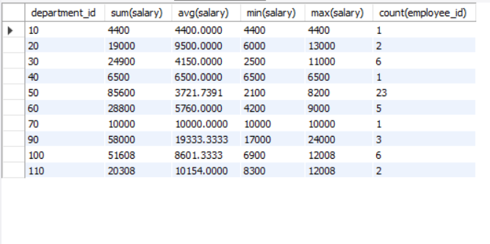

**SUB QUERIES**

-- sub queries

-- city with max population within its country

select Name,Population,CountryCode from city c1

where c1.Population=(select max(c2.Population) from city c2 where c2.CountryCode=c1.CountryCode);

-- CONDITIONAL STATEMENT ( CASE WHEN)

select e1.employee_id, concat(concat(e1.first_name,' '),e1.last_name) as Employee_Name, case when e1.manager_id is not null then

(select concat(concat(e2.first_name,' '),e2.last_name) from emp e2 where e2.employee_id=e1.manager_id) else 'No Manager --> Head of the Employees' end

as Manager_Name from emp e1;

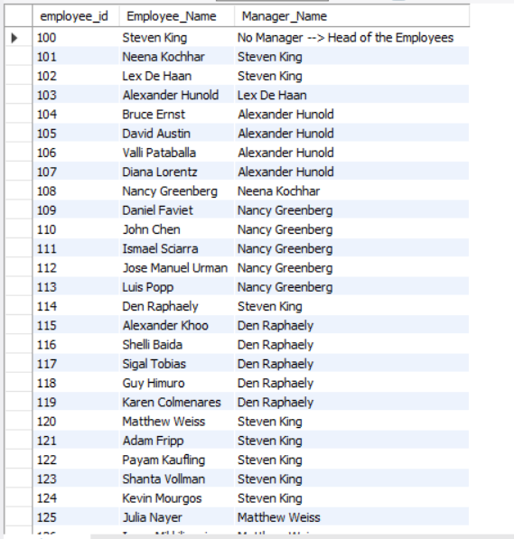

-- SUBQUERIES

select * from emp where department_id in (select department_id from dept where location_id=1700);

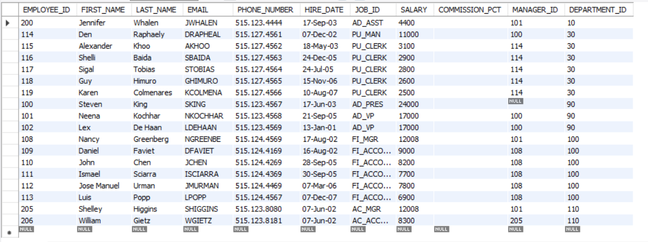

-- "STRING FUNCTIONS ( LENGTH, UPPER, LOWER, REPLACE, TRIM, LTRIM, RTRIM, CONCATENATION, SUBSTRING, LIST AGGREGATION )"

select first_name, length(first_name), upper(first_name), lower(first_name), replace(first_name, 'a','x') from emp;

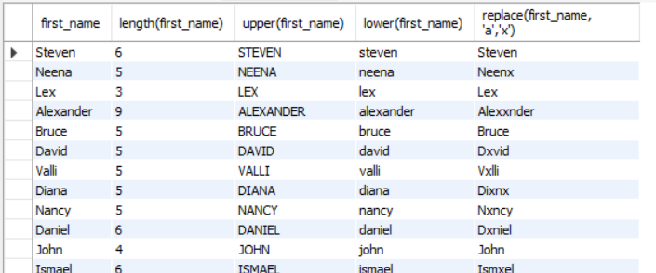

**String Functions**

select District,char_length(District),lcase(District),ucase(District),

REPLACE(District,"bol","alob") from city;

-- "MATHEMATICAL FUNCTIONS (CEIL & FLOOR, RANDOM, SETSEED, ROUND, POWER )"

SELECT CEIL(25.75), floor(25.75), rand(10), round(25.5), round(25.78), power(2,3);

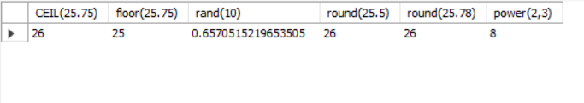

-- "DATE-TIME FUNCTIONS (CURRENT DATE & TIME, AGE, EXTRACT)"

select curdate(), curtime(), current_timestamp(), extract(month from curdate());

